The Path of Promises – Privileged Footsteps to Follow
Heb 10:20 KJV By a new and living way…
Mat 7:14 KJV Because strait is the gate, and narrow is the way…
The gate is where our heart and the narrow way meet.
Rev 3:20 KJV Behold, I stand at the door, and knock…
Joh 10:27 KJV My sheep hear my voice, and I know them, and they follow me
Psa 18:29-32 It is God that girdeth me with strength, and maketh my way perfect.
"My presence shall go with thee, and I will give thee rest." Exo. 33:14
"Thou wilt show me the path of life…" Psa. 16:11
"And the Lord, He it is that doth go before thee..." Deut. 31:8
"Be strong… for the Lord thy God is with thee whithersoever thou goest." Josh. 1:9
Making choices every day…the endeavor is to bring glory to God, to demonstrate our love for Him…
"He will keep the feet of His saints." 1 Sam. 2:9
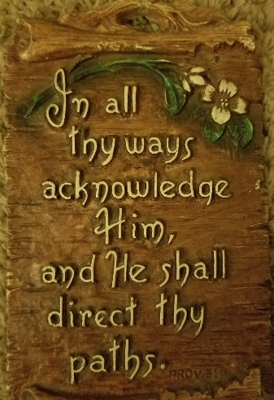
If we have been given to have our right hand in his and take it not, then we, too, are using the narrow way without understanding the ministering of angelic helps…
"I have set the Lord always before me…" Psa. 16:8
… the real strength is not our own, but the Lord’s…
"It is God that … maketh my way perfect… Psa. 18:32,29
… every day we allow Jesus to take our yoke, the burden part…
"He leadeth me in the paths of righteousness for His name's sake." Psa. 23:3
"Yea, though I walk through the valley of the shadow of death..." Psa. 23:4
We feel His nudge … and know it is because we are the objects of His love
"Surely goodness and mercy shall follow me all the days of my life…” Psa. 23:6
"The … meek will He teach His way." Psa. 25:9
… in a sense we are senseless… we think we know so much when we know so very little.
"… him shall He teach in the way that He shall choose." Psa. 25:12
"I will instruct thee and teach thee in the way which thou shalt go" Psa. 32:8
"The steps of a good man are ordered by the Lord…" Psa. 37:23
“If He brought me to it, He will bring me through it”…
"They shall bear thee up … lest thou dash thy foot against a stone." Psa. 91:11,12
If it’s meant for me, then it is up to Thee, O my Lord!”
"And He led them forth by the right way." Psa. 107:7
"Thy Word is a lamp unto my feet, and a light unto my path." Psa. 119:105
"… In all thy ways acknowledge Him, and He shall direct thy paths." Prov. 3:5,6
… trust the Lord with all our heart rather than with all our brain.
"The path of the just is as the shining light…”Prov. 4:18
R624; Hymn 322… "Ah, these are of a royal line,
"… they shall walk, and not faint." Isa 40:31
Where will we find a place where the Lord cannot help us? Where?!
"…when thou walkest through the fire, thou shalt not be burned" Isa. 43:2
"And the Lord shall guide thee continually." Isa. 58:11
"Lo, I am with you alway, even unto the end of the age." Matt. 28:20
…just the right truths revealed and received into all good and honest, humble hearts…
"He calleth his own sheep by name, and leadeth them out." Jno. 10:3
" He goeth before them, and the sheep follow Him: for they know His voice.." Jno. 10:4,5
The plan of God is the footprint of the New Jerusalem. Seeing what shall soon be, does indeed affect how we currently are.
"… he [it] will guide you into all truth… Jno. 16:13
"God …will with the temptation also make a way to escape
‘1 Cor. 10:13
This is a designated path … a work of the Lord in our hearts
Eph 2:10 KJV .. created in Christ Jesus unto good works… we should walk in them.
"Which hope we have as an anchor of the soul,." Heb. 6:19
"He hath said, I will never leave thee nor forsake thee." Heb. 13:5
"Draw nigh to God, and He will draw nigh to you." Jas. 4:8
… you have been … just what the Father was looking for when He revealed the hidden gate…
… it must be found in a daily constancy of promises
"Him that overcometh … he shall go no more out." Rev. 3:12
"Oh! 'tis a pathway rough to choose, A struggle hard to share,
For human pride would still refuse; The nameless trials there… R1263

